October is National Audiology Awareness Month

October is National Audiology Awareness Month and Now Hear This ® encourages physicians to be aware of the importance of good hearing health. The National Institutes of Health’s National Institute on Deafness and Other Communication Disorders states that approximately 28.8 million Americans could benefit from the use of hearing aids. While age is often cited as a factor, there are growing numbers of younger people reporting hearing difficulties.
A study published by the Lancet Commission on Dementia Prevention, Intervention and Care untreated hearing loss as a mid-life risk factor. There is also a link between untreated hearing loss and falls. According to a study by Johns Hopkins University School of Medicine, an increase in hearing loss, for instance going from normal hearing to an untreated mild hearing loss, is associated with a 3-fold increase in fall risk.
One of the factors in maintaining healthy hearing is being conscious of the degree and amount of loud sound exposure. More than 40 million Americans, aged 20 to 69, have some type of hearing loss with approximately 10 million of those attributable to noise-induced hearing loss. This hearing loss is often caused by damage to the stereocilia of the inner ear and is often permanent, although preventable. If someone can’t avoid loud sounds they should wear hearing protection. An audiologist can help identify the right hearing protection for the situation, including custom hearing protection for the right fit and sound quality.
The American Academy of Audiology states that lengthy or repeated exposure to noise above 85 decibels, can damage hearing. To put that into perspective, noise from fireworks can reach up to 155 decibels. An amplified music concert and an MP3 player with the volume turned all the way up can be as high (or higher) as 120 decibels. Lawn mowers are around 85 decibels and chain saws can be 115-120 decibels. Compare these with normal conversation that is around 60-65 decibels.

The four main ways for patients to protect their hearing are:
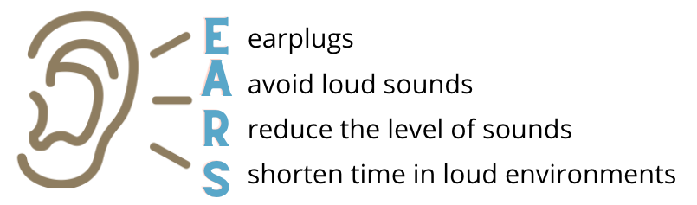
Our Audiologist educates patients about safe versus unsafe levels for listening. We utilize tools and share resources that empower patients to protect their hearing. Additionally, we perform hearing evaluations and facilitate aural rehabilitation efforts for hearing loss, tinnitus, and hyperacusis.

Accepting New Patients!
Our office is open and continues to safely serve our community following CDC guidelines.

