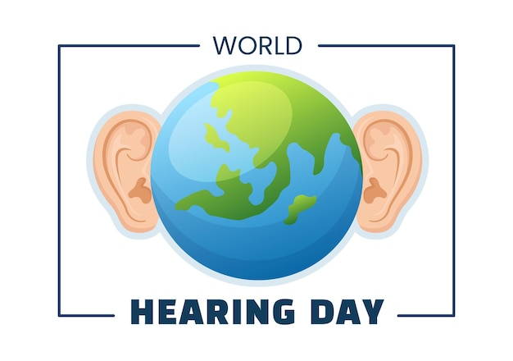**What is World Hearing Day?**

World Hearing Day is on **March 3rd, 2024**. It is an annual campaign by the Office of Prevention of Blindness and Deafness of the World Health Organization (WHO). The objective is to raise awareness on how to prevent deafness and hearing loss and promote ear and hearing care across the world.

This year’s theme is ***“Changing Mindsets: Let’s make ear and hearing care a reality for all!”.*** World hearing day 2024 will focus on overcoming the challenges posed by societal misperceptions and stigmatizing mindsets through awareness raising and information sharing, targeted at the public and health care providers.

**Advocating for Hearing Healthcare**

At Now Hear This, we advocate for hearing healthcare by offering a wide variety of price points to make hearing aids as accessible as possible. **We also work with Hearing Charities of America (HCA) to address the demand for hearing aids among low-income individuals.** By participating in the Hearing Aid Project, we can support and improve the quality of life for those with hearing loss.

**Not So Fun Facts:**

* Globally, over 80% of ear and hearing care needs remain unmet
* Unaddressed hearing loss poses an annual cost of nearly US $1 trillion globally
* About 22 million Americans are exposed to hazardous noise levels in the workplace
* People with hearing loss wait an average of 7 years before seeking help
* Those with unaided hearing loss **earned on average $20,000 less annually** than those who used hearing aids or cochlear implants

**It is our job as providers to not only educate but advocate for the public and our patients who are struggling with hearing loss!**

Ghebreyesus, Tedros Adhanom. “World Hearing Day 2024.” *World Health Organization*, World Health Organization, www.who.int/campaigns/world-hearing-day/2024. Accessed 15 Feb. 2024.