**Occupational Noise Exposure**

Occupational noise exposure refers to the amount of noise employees are exposed to while on the job. **The CDC estimates that approximately 22 million workers are exposed to damaging noise levels each year.** Approximately 33% of working age adults with a history of noise exposure have some amount of hearing loss. Hearing loss due to noise exposure is sensorineural hearing loss and is permanent in nature. There is a correlation between sensorineural hearing loss and cognitive decline. This is why hearing protection is so important.

**The workplace might be dangerously loud if your patients report experiencing the following:**

* 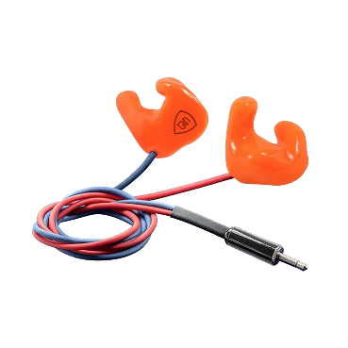Ringing or buzzing in the ears when they leave work
* Experiencing a temporary shift in hearing when they leave work
* Shouting to hear/communicate with coworkers only 3 feet away

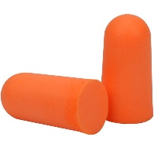**Have your patients be proactive and protect their hearing!**

* Wear properly fitting hearing protection
* Monitor hearing with annual hearing screenings
* 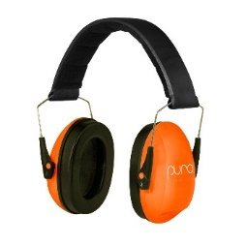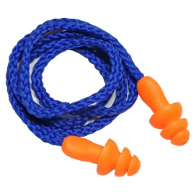Take frequent breaks away from the noise

**Types of Hearing protection:**

* disposable foam plugs
* custom molded hearing protection
* earmuffs
* reusable hearing protection

It is also important to note that noise exposure can happen after work hours; motorcyclists, musicians, and many other hobbyists should consider hearing protection as sensorineural hearing loss due to noise is irreversible long-term.

**Do you have a patient who needs custom hearing protection? We can help! We provide all types of custom hearing protection including traditional plugs, musician’s plugs, sleep plugs, and swim plugs. We also recommend an updated hearing evaluation for any patient with a history of prolonged noise exposure.**

*Occupational noise exposure - overview*. Occupational Safety and Health Administration. (n.d.-a). https://www.osha.gov/noise