**Tinnitus: Why is there Ringing in my Ears?**

**Statistics**

Approximately 25 million Americans experience tinnitus, making it one of the most common health conditions in the United States. Approximately 5 million of those people have chronic, bothersome tinnitus and 2 million have debilitating tinnitus. **Almost 90% of people with tinnitus also have some hearing loss.**

**What is tinnitus?**

Tinnitus is the perception of sound, most commonly ringing, when no external noise is present in the environment. Tinnitus may also be perceived as buzzing, roaring, humming, pulsing, or even music.

**What causes tinnitus?**

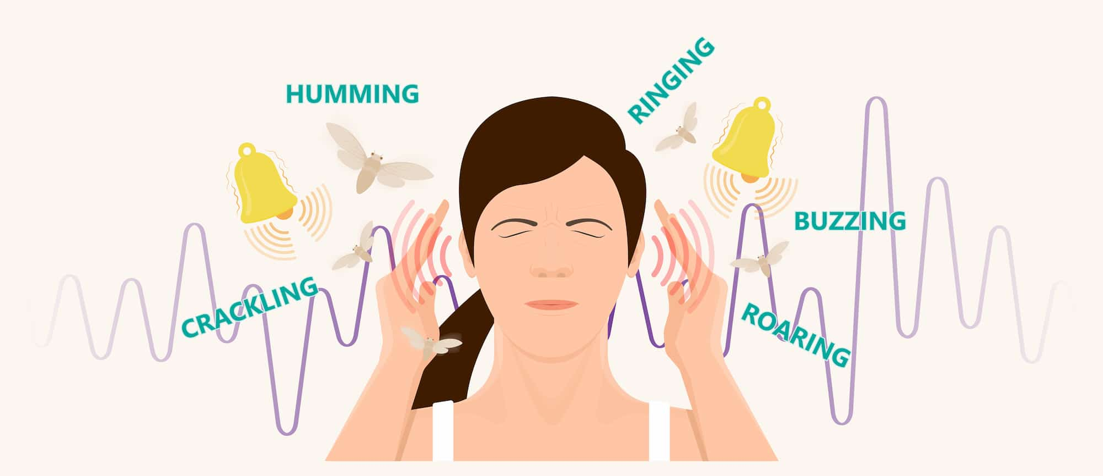Tinnitus is the result of an underlying health condition. Possible causes of tinnitus include:

* Age-related hearing loss
* Noise exposure
* Medication side effects
* Dental issues
* Wax impactions
* Ear infections
* And more!!

**Who Should I see for Help?**

**Audiologists are hearing care professionals trained to diagnose, manage and treat disorders of the auditory system, including tinnitus. Scheduling an evaluation with an audiologist is a great first step in getting help with tinnitus.** An audiologist may also refer the patient to other professionals, such as psychologists, otolaryngologists, and dentists, if needed.

**Do you have a patient concerned about their tinnitus? Encourage them to schedule an appointment with us! We recommend a baseline hearing test for all patients with tinnitus and a tinnitus evaluation for patients with chronic, bothersome tinnitus.**

*American Tinnitus Association*. American Tinnitus Association | The ATA is a non-profit that empowers tinnitus patients, health-care providers, and researchers. (2024, August 23). https://www.ata.org/