Vertigo: What does dizziness have to do with the ears?
Vertigo is the sensation that the environment is spinning. Vertigo is not the same as feeling lightheaded. Those with vertigo feel as if they are actually moving. Vertigo may be accompanied by other symptoms including nausea and vomiting, hearing loss in one or both ears, tinnitus, pressure or fullness in the ear, loss of balance, and more. These symptoms can indicate an issue with the inner ear’s vestibular system. The inner ear houses the auditory and vestibular system. The vestibular system is responsible for balance. Issues within the vestibular system most often result in patients reporting concerns of vertigo and or dizziness.

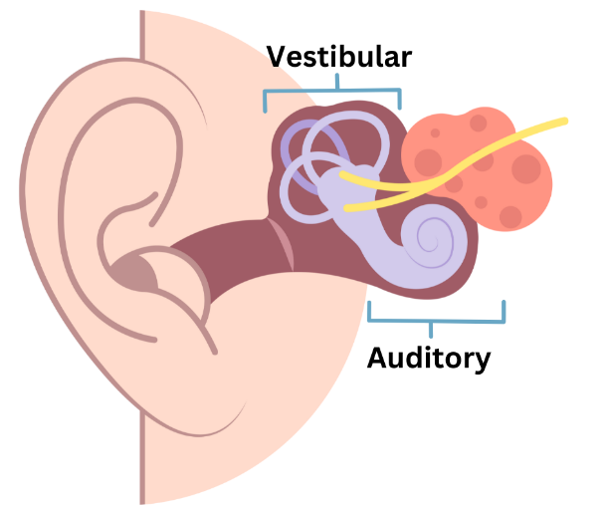
Common Causes of Dizziness
- Benign paroxysmal positional vertigo (BPPV)
- Meniere’s Disease
- Vestibular Neuritis
- Labyrinthitis
- Vestibular Migraine
- Vestibular Schwannoma
- Stroke
- Traumatic Brain Injury
Other causes of dizziness unrelated to the ear include low blood pressure, medication side effects, dehydration, anxiety and stress. Of course, this is why a thorough case history is so important.
Dizziness is the most common complaint of patients over 70 years of age.
Iwasaki S, Yamasoba T. Dizziness and Imbalance in the Elderly: Age-related Decline in the Vestibular System. Aging Dis. 2014 Feb 9;6(1):38-47. doi: 10.14336/AD.2014.0128. PMID: 25657851; PMCID: PMC4306472.
When should patients have additional testing?
If dizziness is accompanied by changes in hearing, ringing in the ears, or pressure/fullness in the ears it is recommended that the patient have a hearing evaluation with an audiologist. These symptoms may indicate an issue with the inner ear. At that appointment, an audiologist might also recommend vestibular testing, which involves a series of tests that help determine if and what vestibular organs are causing the dizziness. Patients with dizziness and ear related symptoms should also be evaluated by ENT.
Have a patient with dizziness and ear related symptoms? Refer them to us for a hearing evaluation. We will perform a thorough case history, perform a thorough hearing evaluation and counsel on the next best steps. We also send a detailed report to the referring physician.

