**COVID-19 and Hearing Loss**

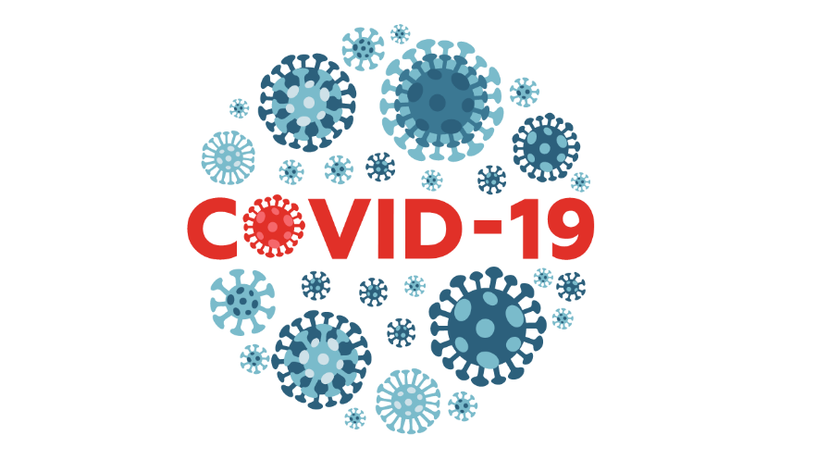A recent (2024) study reveals that COVID-19 significantly increases the risk of hearing loss in young adults, tripling the likelihood of developing the condition. The research, conducted in South Korea and including 6.7 million young adults, focused on the connection between COVID-19 and hearing issues, including sudden sensorineural hearing loss (SSNHL).

**Key Findings:**

* **COVID-19 triples hearing loss risk**: Young adults with COVID-19 are three times more likely to develop hearing loss compared to those without the virus.
* **Long COVID concerns**: The study highlights the need for further investigation into long-term auditory health impacts of COVID-19, including how the virus may contribute to hearing problems.
* **Viral impact**: Sensorineural hearing loss (HL) is suspected to be linked to COVID-19’s effects on the brainstem and may be a non-specific symptom of the disease.

**Study Details:**

* **Outcomes**: The study monitored composite hearing loss and sudden sensorineural hearing loss (SSNHL), defined by the rapid loss of hearing by at least 30 decibels within 72 hours.
* **Conclusion**: The study underscores the urgent need for ongoing research into the long-term auditory effects of COVID-19, as sudden hearing loss among infected individuals could represent a significant public health concern.

**Our Takeaway:**

We recommend patients who experience sickness followed by a change in hearing obtain a baseline hearing evaluation and monitoring. Sensorineural hearing loss is typically permanent and may require additional monitoring or intervention.

**As seen in this research, hearing loss can impact both young and old adults!**

**Have a patient who struggles with their hearing? Send them our way.**

Hye Jun Kim, Seogsong Jeong, Kyuwoong Kim, Joon Don Lee, Yun Hwan Oh, Michelle J. Suh, (2024).

Incidence of hearing loss following COVID-19 among young adults in South Korea: a nationwide cohort study,

eClinicalMedicine, Volume 75, https://doi.org/10.1016/j.eclinm.2024.102759.