Importance of Hearing Screenings
Hearing loss is the third most prevalent chronic condition as we age and is more widespread than diabetes or cancer (CDC 2016). Anyone over the age of 60 should have a hearing evaluation. Educating your patients and performing hearing screenings at your clinic will help catch early signs of hearing loss.

Comorbidities
Hearing loss is linked to a multitude of health conditions: diabetes, high blood pressure, autoimmune disease, and various heart conditions. Patients who have these conditions may be more at risk of hearing loss.
People with hearing loss are at an increased risk of falling and hospitalization as well as poor mental health. Testing your patients’ hearing regularly and referring them for a full evaluation can help reduce cognitive decline and improve their everyday quality of life.
Hearing Screenings
Newborn hearing screenings have significantly improved the diagnosis of childhood hearing loss and reduced the average age of diagnosis from 24-30 months to 2-3 months (Young A, Ng M, 2023), but adult screenings at routine physicals are just as important in catching acquired hearing loss at its earliest stages.
About 22% of U.S. adults have hearing loss, but the prevalence increases significantly with age (Lin FR, Niparko JK, Ferrucci, L, 2011). Despite this high percentage, many adults with hearing problems do not seek treatment, and less than 20% have had a hearing test in the past five years” (ASHA, 2021).
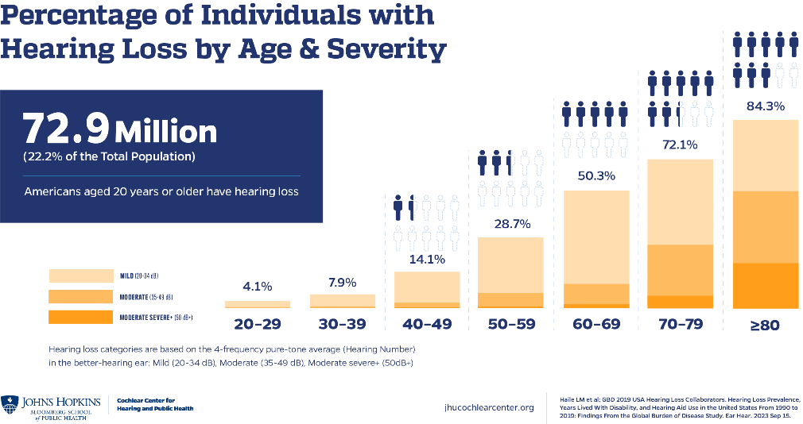

Patients showing signs of hearing loss should be referred for a hearing evaluation.

WE ARE ACCEPTING NEW PATIENTS
Sources:
The hidden risks of hearing loss. Johns Hopkins Medicine. (2024, August 1). https://www.hopkinsmedicine.org/health/wellness-and-prevention/the-hidden-risks-of-hearing-loss
Hearing loss. Dementia Statistics Hub. (2024, August 1). https://dementiastatistics.org/statistics/hearing-loss/
Lin FR, Niparko JK, Ferrucci L. Hearing loss prevalence in the United States. Arch Intern Med. 2011 Nov 14;171(20):1851-2. doi: 10.1001/archinternmed.2011.506. PMID: 22083573; PMCID: PMC3564588.
“New Poll of U.S. Adults Reveals Widespread Inaction on Hearing Loss.” American Speech-Language-Hearing Association, American Speech-Language-Hearing Association

