Auracast in Hearing Aids – A Game Changer
What is Auracast and why is it important? How does it help hearing aid users?

What is Auracast?
Auracast is a new Bluetooth Low Energy feature that allows audio to be broadcast to an unlimited number of compatible devices simultaneously. When using Auracast transmission, users can connect directly to the Auracast-compatible microphone, allowing the audio from the mic to go directly into the hearing aids. This allows for crisper sound quality and reduced background noise for the listener, which is a common problem with people who have hearing loss.

How Does Auracast Benefit Hearing Aid Users?
- Better Speech-in-Noise Understanding: Hearing aid users found 40% improvement in sound quality and speech intelligibility when streaming audio compared to hearing in their ambient environment (Frontiers, 2023).
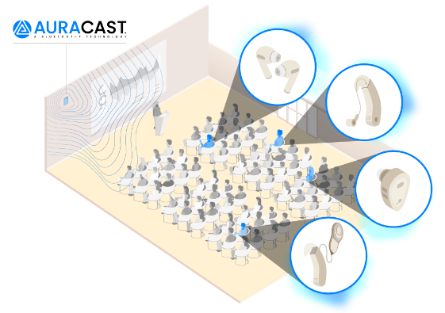
- Universally Accessible: Eventually, Auracast will be available for people with and without a Smartphone. Since it is relatively inexpensive to implement Auracast, more businesses are likely to become more accessible for hearing-aid users.
- Less Battery Drain: Auracast requires less power than traditional Bluetooth streaming with the use of Low Energy Bluetooth resulting in a longer hearing aid battery life.
- Better Hearing in Public Places: Noisy environments, such as an airport that has a PA system, will be able implement Auracast broadcasting more seamlessly making public audio sources more accessible to ensure that everyone, regardless of their hearing needs, can engage with the content. Auracast is expected to grow and be more readily available publicly in the next 3-5 years.

Refer patients who may benefit from Auracast-ready hearing aids for a consultation!
919-256-2898
Sources:
Linner, “Telecoil vs. Auracast: Comparing Technologies for Hearing Aid Users -.”
Linner, Linner, 15 July 2024
Soundly, “How Auracast and Bluetooth Le Will Change Hearing Aids.”
Fabry, David. Future Forward: More Connectivity Enhances Hearing Aid Technology,
ASHA Wire, 13 Mar. 2025
Diehl, P. U., Zilly, H., Sattler, F., Singer, Y., Kepp, K., Berry, M., Hasemann, H., Zippel, M., Kaya, M., Meyer-Rachner, P., Pudszuhn, A., Hofmann, V. M., Vormann, M., & Sprengel, E. (2023). Deep learning–based denoising streamed from mobile phones improves speech-in-noise understanding for hearing aid users. Frontiers in Medical Engineering. (or arXiv preprint)

