Noise Induced Hearing Loss (NIHL) in Teens – How Can This Be Prevented?
Researchers have reported the prevalence of Noise-Induced Hearing Loss (NIHL) among American adolescents ranges between 12.8% and 17.5% (Eichwald, Scinicariello, 2020). Even a mild hearing loss can impact auditory perception and cognitive ability which is essential especially in a learning environment.

Why are Teens More Prone to NIHL?
Long or repeated exposure to sounds at or above 85 decibels (dB) can cause both temporary and permanent hearing loss. Some more common sources of dangerous noise levels for teenagers include:
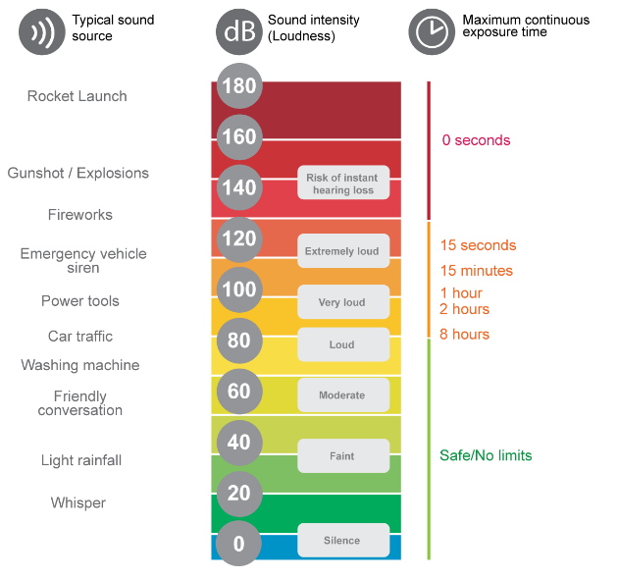
- Personal Listening Devices: AirPods can reach over 100dB at full volume which can be compared to noise levels emitted by a jackhammer or motorcycle. Less than one hour of exposure at this volume can cause hearing loss. (London Ear Lab)
- Sporting events: Depending on the setting and whether the game is inside or outside, volume levels typically range from 90-110dB. 15 minutes of exposure at 110 dB can cause hearing loss. (London Ear Lab)
- Concerts and Live Music: Sound levels regularly range from 90-122 dB depending on the concert setting and music style. 15 seconds of being exposed to 120dB noise can cause hearing loss. (London Ear Lab)

How can NIHL be Prevented?
- Headphone Safety: Companies like Apple have recently made features to advance hearing safety. Built-in phone speakers can be altered to have a set maximum volume. Headphone safety alerts will notify users if they have exceeded safe listening volumes and automatically reduce loud audio.
- Hearing Protection: Foam earplugs are offered at most concert venues, but reusable earplugs have become more popular, especially custom plugs that provide the most comfortable and secure fit.
- Regular Hearing Screenings and Education: Routinely monitoring hearing at annual physicals can ensure any changes in hearing are caught as early as possible. Educating younger adults about noise exposure is essential in reducing avoidable hearing challenges as they age.

For more information on NIHL prevention and custom ear protection, call us!
919-256-2898
Sources:
Eichwald J, Scinicariello F. Survey of Teen Noise Exposure and Efforts to Protect Hearing at School - United States, 2020. MMWR Morb Mortal Wkly Rep. 2020 Dec 4;69(48):1822-1826. doi: 10.15585/mmwr.mm6948a5. PMID: 33270617; PMCID: PMC7714025.
London Ear Lab “Safe Exposure Times.” Sound Lab, londonearlab.com/sound-lab-en/safe-exposure-times/. Accessed 15 Dec. 2025.

