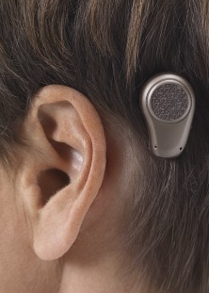
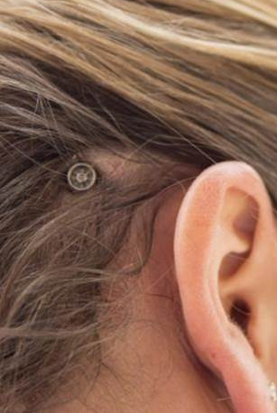
Bone-Anchored Hearing Aids (BAHAs):
What are they and who could benefit from them?
Traditional hearing aids amplify sound through your middle ear.
Bone-anchored hearing aids, or BAHAs, are a surgically implanted devices
that bypass the middle ear to deliver sound straight to the auditory system.

How do BAHAs work?
BAHAs have three parts:
- A titanium implanted portion – a small screw implanted into the bone behind the ear with hearing loss.
- An external abutment – a cone-shaped part that connects with the screw
- The sound processor – the hearing device that externally clips onto the abutment.

The sound processor picks up external sound and converts it into vibrations. The vibrations are transmitted through the abutment and stimulate the titanium implant. This allows the sound to be delivered directly to the inner ear, bypassing the dysfunctional middle ear.

Who is a Candidate?
- Chronic Ear Infections: Traditional hearing aids that are placed in the ear canal may aggravate infections. BAHAs, which leave the ear canal open, could be a suitable alternative.
- Congenital Hearing Loss: If someone has an ear abnormality or malformation, they may benefit from a BAHA. Sometimes an ear canal may not be fully developed, which can make it difficult for the patient to be fit with traditional hearing aids.
- Single-Sided Deafness: When one ear has a hearing loss, with traditional hearing aids, the patient would need to wear two devices – the hearing aid on the bad ear would pick up the signal and send it over to the good ear. With BAHAs, the patient would only need one device on the bad side.
- Other conditions that may cause hearing loss that can be treated by a BAHA include: Cholesteatoma, Acoustic Neuroma, Meniere’s Disease, etc.

Have a patient who may be a candidate? Send them our way! We provide comprehensive BAHA evaluations and work on existing BAHAs!
Sources: “Bone Anchored Hearing Aid.” UC Irvine Medical Center, www.ent.uci.edu/clinical-specialties/ear-surgery/bone-anchored-hearing-aid.asp. Accessed 17 Feb. 2025.
Cleveland Clinic medical. “How Bone-Anchored Hearing Aids Treat Hearing Loss.” Cleveland Clinic, 20 Jan. 2025, my.clevelandclinic.org/health/treatments/14794-bone-anchored-auditory-implant.

