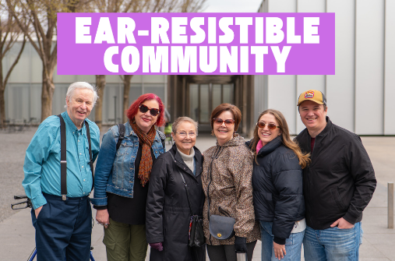
Hearing Loss Support Group
Hearing loss can have a drastic impact on someone’s mental wellbeing. Communication can become more difficult, sometimes causing the person with hearing loss to withdraw from social activities and become isolated. According to research, there is a strong relationship between depression and hearing loss among U.S. adults.

How are Depression and Hearing Loss Linked?
- Nearly 33 percent of adults 70 years and older have a hearing loss that impacts daily communication.
- Hearing loss can make it more difficult to interact with peers and can lead to decreased social engagement, depression, or bad moods.
- Untreated hearing loss, social isolation, and depression can all contribute to an overall poorer quality of life.
- Regular hearing aid use has been associated with a lower prevalence of depression.
- Some studies have shown reductions in depressive symptoms within three months of hearing aid use.


Ear-Resistible Community!

Our Hearing Loss Support Group was started by Dr. Samantha Shopovick, AuD. “Ear-Resistible Community” is dedicated to providing a safe, welcoming, and fun space for individuals with hearing loss to connect, share experiences and support each other. This community can be beneficial to long-time hearing aid users as well as those who are newly experiencing hearing challenges. It can be difficult for family members and friends with normal hearing to fully understand the struggles of hearing loss. Having a support group will not only boost one’s mental health but can increase social activities and provide access to helpful resources about hearing loss.

Join the support group via Meetup!

https://www.meetup.com/hearing-loss-support-group/

Sources: “Depression and Hearing Loss.” American Academy of Audiology, 27 May 2022, www.audiology.org/consumers-and-patients/hearing-and-balance/depression-and-hearing-loss/.

