Strokes and Speech Perception
Strokes often create drastic side effects to one’s bodily functions, especially depending on where in the brain the lesion occurs. While muscle weakness, trouble walking, and slurred speech are some of the main side effects, there are various difficulties a stroke survivor may encounter, one of which being an increased struggle with hearing and speech perception.

How are Strokes and Auditory Processing Connected?
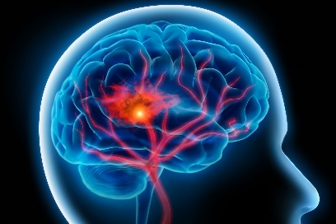
For the majority of the population, the left hemisphere of the brain contains the language center.
For strokes that occur in the language-centered hemisphere, the more noticeable side effect would likely be slurred speech, but perception can also be targeted and often can go unnoticed when compared to other side effects of the stroke. Language perception and production can drastically impact one’s quality of life and should be considered when someone suffers from a stroke, especially in the left hemisphere. If a patient is not evaluated for hearing or auditory processing disorders following a stroke, it may impact their communication and rehabilitation process.

Real Life Applications
A patient at our clinic suffered from a left brainstem stroke in March and had noted a change in hearing afterwards. When comparing the hearing test results with an evaluation conducted 8 months prior, the pure tone thresholds remained stable for both ears, but word recognition decreased from 92% to 56% in the right ear. The left ear remained stable. Although the patient was still hearing at the same intensity level, they showed a significant decline in their ability to comprehend speech in the ear opposite from the site of the stroke. Studies of populations with strokes indicate that hearing loss is very common, while in the general population, a past history of strokes increases the likelihood of having a hearing loss.

Stroke, Hearing Loss, and Cognitive Decline
Untreated hearing loss is connected to an increased risk of dementia. Stroke also increases the risk of vascular dementia and accelerated cognitive decline. If someone who has suffered from a stroke experiences auditory deficits as a result, they may be even more vulnerable to developing dementia. While there are so many obstacles following a stroke, ensuring the patient can communicate effectively during their recovery is vital for their rehabilitation outcome and quality of life in the future. Referring your patients for a hearing evaluation can help rule out any auditory complications.

Sources:
Koohi, N., Vickers, D. A., Utoomprurkporn, N., Werring, D. J., & Bamiou, D. (2019). A Hearing Screening Protocol for Stroke Patients: an Exploratory study. Frontiers in Neurology, 10. https://doi.org/10.3389/fneur.2019.00842
Bamiou, D. E. (2015). Hearing disorders in stroke. Handbook of Clinical Neurology, 633–647. https://doi.org/10.1016/b978-0-444-62630-1.00035-4
Clinic, C. (2025, April 22). What Are the Differences in Left vs. Right Brain Strokes? Cleveland Clinic. https://health.clevelandclinic.org/left-vs-right-brain-stroke

