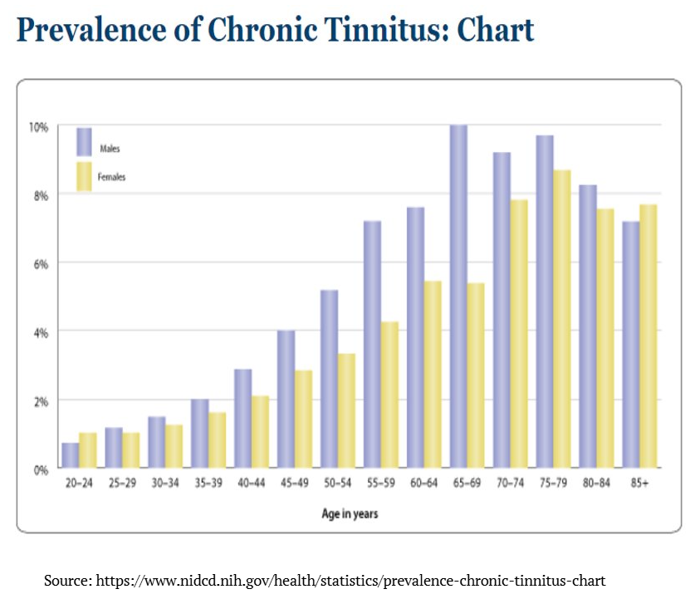
Tinnitus + Lifestyle Changes
Tinnitus affects about 15% to 20% of people and is especially common in older adults (Mayo Clinic, 2022). Although there is no known cure for tinnitus, there are some management strategies / lifestyle changes that may ease symptoms; this tidbit will focus on nutrition and diet.

What causes Tinnitus?
Tinnitus is commonly correlated with hearing loss. 90% of people with tinnitus also have hearing loss (Minnesota Department of Human Services, 2022). Inner ear hair cells move when the ear receives sound stimuli which then triggers electrical signals to travel along the auditory nerve to the brain. If the hair cells are damaged, they can produce random electrical impulses without the presence of external sound, causing tinnitus (Mayo Clinic, 2022). Typically, when evaluating a hearing test, the hearing loss aligns with the frequency of the phantom sound the patient is hearing with their tinnitus. Other causes of tinnitus range from ear infections, head injuries, medications, blood vessel disorders, and other conditions. It is also correlated with caffeine and alcohol intake, tobacco use, drug use, fatigue, anxiety, stress and even the foods you eat.

Tinnitus + Diet Considerations
- The inner ear relies on a healthy blood supply for proper function and certain foods can impact vascular health, in turn affecting auditory function. As we tell our patients, anything that is good for the heart is good for the ears.
- Medications can cause or exacerbate existing tinnitus! We always recommend our tinnitus patients consult with their PCP regarding these interactions, and we also recommend the American Tinnitus Association for those who want to learn more!
- In a study using UK Biobank data, various nutrients were measured alongside the participants reported health and tinnitus questionnaires. Higher intake of vitamin B12 and a high protein diet was associated with reduced odds of tinnitus while higher intakes of calcium, iron, and fat were associated with increased odds of tinnitus. (Dawes, Piers, et al, 2019)
- In a 10-year longitudinal study conducted by Dr. Sharon Curhan following 73,000 women, a few connections were made specifically between tinnitus prevalence and seafood consumption. Regularly eating tuna, light-meat fish, and shellfish were each associated with lower risk of persistent tinnitus while eating dark-meat fish and fish oil supplement use was associated with an increased risk (Dr. Curhan, 2024).

Healthy Heart, Healthy Ears
There is currently no cure for tinnitus currently, however there are many ways to manage and relieve symptoms.
We are happy to help! Please send your tinnitus patients our way for comprehensive and personalized care.

Sources:
Curhan, Sharon G, et al. “Longitudinal Study of seafood and fish oil supplement intake and risk of persistent tinnitus.” The American Journal of Clinical Nutrition, vol. 120, no. 6, 28 Sept. 2024, pp. 1409–1418, https://doi.org/10.1016/j.ajcnut.2024.09.028.
Dawes, Piers, et al. “Relationship between diet, tinnitus, and hearing difficulties.” Ear &amp; Hearing, vol. 41, no. 2, 25 July 2019, pp. 289–299, https://doi.org/10.1097/aud.0000000000000765.
Hamilton, Melanie. “How Seafood in Diet Affects Tinnitus Risk: An Interview with Sharon Curhan, MD, SCM.” The Hearing Review, 29 Oct. 2024, hearingreview.com/hearing-loss/tinnitus/how-seafood-in-diet-affects-tinnitus-risk-an-interview-with-sharon-curhan-md-scm.
“Tinnitus.” Deaf and Hard of Hearing, Minnesota Department of Human Services. 1 Apr. 2022, mn.gov/deaf-hard-of-hearing/hearing-loss/tinnitus/.
“Tinnitus.” Mayo Clinic, Mayo Foundation for Medical Education and Research, 30 Nov. 2022, www.mayoclinic.org/diseases-conditions/tinnitus/symptoms-causes/syc-20350156.

